Christeen Safar

CSD - 340

03/25/2023

**Module 3 Assignment 3.3- Assignment: Build a Webpage Exercise, Part 3**

**Assignment: Build a Webpage Exercise, Part 3**

In this assignment, you will be expanding on what you learned in Part 2 by creating ordered and unordered lists, applying borders to lists, and adding “return to Landing Page” navigation.

**Resource Link:**

1. CSS Lists: <https://www.w3schools.com/css/css_list.asp>

**GitHub Link:**

<https://github.com/ChristeenSS/csd-340.git>

**GitHub Pages:**

<https://christeenss.github.io/csd-340/>

**1. Assignment Instructions**

* + Create a new folder under your local csd-340 folder (repository)  and name it module-3
  + Create a new HTML document and name it LastName_Mod3_3.html, add your name and assignment number (documentation), and add it to your module-3 directory
    - All HTML code will go in this file
  + Create a new CSS document and name it LastName_Mod3_3.css and add it to your module-3 directory
    - All CSS styling will go in this file
  + Add a link in the index.html file to the 3.3 html file
    - Hint: refer back to assignment 3.2 if you are confused about what this item is referencing
  + Contents of LastName_Mod3_3.html
    - Create an empty HTML document (follow the code we used in Module 2)
    - Give the HTML document a title of “CSD 340 Web Development with HTML and CSS”
      * This will be placed in the head/title element
    - Add a link to the LastName_Mod3_3.css file in the HTML documents head element
    - Add a main div to the body of the HTML document with an id of “container”
    - Container div
      * Add an h1 tag and give it a text value of “Assignment 3.3: Build a Web Page Exercise - Part 3”
        + Center the text on the page
      * On a new line create two side-by-side divs
        + Give each div a width of 45%
      * Left div
        + Add an h3 tag to the left div with a text value of “Top 10 Favorite Books
        + On a new line, make a top ten list of your favorite books using an ordered list
      * Right div
        + Add an h3 tag to the right div with a text value of “5 Things I’ve Learned Since the Course Started”
        + On a new line, list five things you’ve learned since the course started using an unordered list
      * Underneath the side-by-side divs add a new div with a width of 100%
      * Give this div a margin-top of 60%
      * Last div
        + Add a link back to your landing/portal page
        + When a user selects this link, they should be navigated back to the index page. This link should be floated to the right.

same directory = "sam.html"

subdirectory = "mod4/sam.html"

parent directory = "../sam.html"

<!DOCTYPE html>

<html lang="en">

  <head>

    <a name="top"></a>

    <meta charset="UTF-8" />

    <meta http-equiv="X-UA-Compatible" content="IE=edge" />

    <meta name="viewport" content="width=device-width, initial-scale=1.0" />

    <title>CSD 340 Web Development with HTML and CSS</title>

    <link href="Safar_Mod3_3.css" type="text/css" rel="stylesheet" />

    <link rel="preconnect" href="https://fonts.googleapis.com">

    <link rel="preconnect" href="https://fonts.gstatic.com" crossorigin>

    <link href="https://fonts.googleapis.com/css2?family=Oswald:wght@300;400;500;700&display=swap" rel="stylesheet">

</head>

  <body>

    <main div id="”container”"></div>

        <h1>Assignment 3.3: Build a Web Page Exercise - Part 3</h1>

       <div class="div_1">

           <h3>Top 10 Favorite Movies  </h3>

            <ol>

                <li>Gone with rhe Wind</li>

                <li>Breakfast at Tiffany's</li>

                <li>Pride and Prejudice</li>

                <li>Up Close and Personal</li>

                <li>You've Got Mail</li>

                <li>The Sound of the Music</li>

                <li>Message in a Bottle</li>

                <li>Beautiful Minds</li>

                <li>Pretty Woman</li>

                <li>Schindler's List</li>

            </ol>

        </div>

        <div class="div_2">

            <h3>5 Things I've Learned Since the Course Started </h3>

            <ul>

                <li>100 Things Every Designer Needs To Know About People</li>

                <li>HTML & CSS: Design and Build Websites</li>

                <li>Atomic Design</li>

                <li>GitHub Pages</li>

                <li>bioSite: Web Deployment</li>

            </ul>

        </div>

<div class="div_3"></div>

<div class="div_4">

<a href="https://www.bellevue.edu/" target="_blank">Degrees</a>

<br>

<a href="#top">Back to top</a></div>

  </body>

</html>

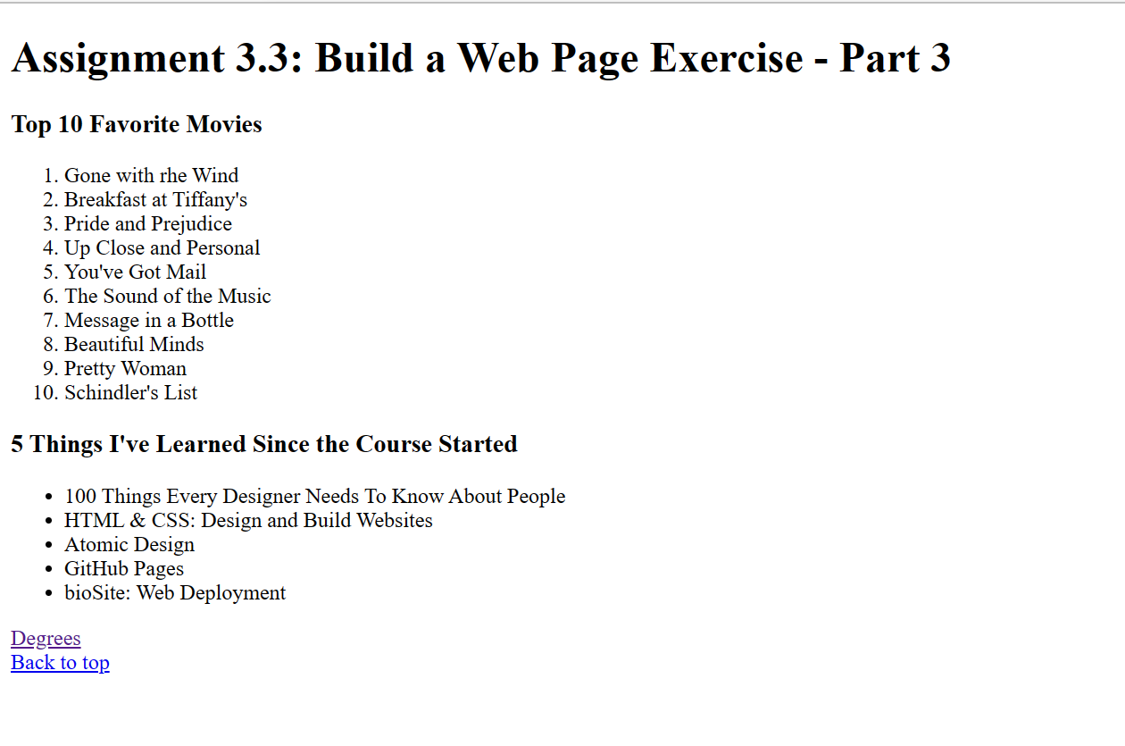

* **Contents of LastName_Mod3_3.css**
  + The h1 title must be centered on the page
  + The side-by-side divs must have a width of 45%
  + Set the width of the last div to 100%
  + Give the last div a margin-top of 60%
  + Set the weight of the h3 tags to 500
  + Set the weight of the lists to 300
  + Apply a 1px solid red border with a 15px border-radius to the ordered list and its' title.
  + Give the ordered list a padding of 10px (the numbers will need to be inside the border; research list-style and list-style-position)
  + Apply 1 px dashed red border with a 15px border-radius to the unordered list and its' title.
  + Give the unordered list a padding of 10px and change the bullet points to upper-roman (research list-style and list-style-position)
  + Add :hover to the links and show the underlines when a cursor hovers over the links
  + Give the bottom div a css value of float right and a margin-bottom of 20px

body {

    font-family: 'Oswald', Verdana, Arial, sans-serif;

}

h1 {

    text-align:center;

}

.div_1 {

    font-weight: 500;

    width: 45%;

    float: left;

    border: 1px solid;

    border-radius: 15px;

    border-color: red;

    padding: 10px;

}

.div_2 {

    font-weight: 500;

    width: 45%;

    float: right;

    border: 1px dashed;

    border-radius: 15px;

    border-color: red;

    padding: 10px;

}

.div_3 {

    width: 100%;

    margin-top: 60%;

}

.div_4 {

    float: right;

    margin-bottom: 20px;

}

ul {

    font-weight: 300;

    list-style: upper-roman;

    list-style-position: inside;

}

ol {

    font-weight: 300;

    list-style-position: inside;

}

a {

    text-decoration: none;

    float: right;

    margin-bottom: 20px;

}

a:hover {

    text-decoration: underline;

}

